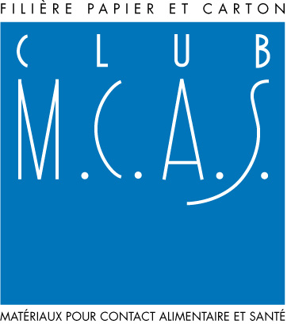
MATERIALS AND CONVERTED PAPER - BOARD ARTICLES
INTENDED FOR FOOD CONTACT

QUESTIONNAIRE TO HELP IN THE DEFINITION OF CUSTOMERS NEEDS ON FOOD CONTACT MATTERS

Regulation reference :Regulation (EC) No 1935/2004 of 2004/10/27 and the French decrees : No 2007-766 of 2007/05/10 and No 92-631 of 1992/07/08 modified

Customer:

Activity:
- Converter :
- Distributor, importer or trader:
  - of materials
  - of converted materials (packaging or others)
- End user

Food to be packed, or intended to come into contact:

- DESCRIPTION OF THE REQUEST

Components description and function of the packaging system or of the article

- ARTICLE CONCERNED

If the article is a packaging, what is its end use?

- Primary packaging
- Secondary packaging⁴
- Tertiary packaging⁴

The paper or the board material, or the converted article, is intended to be printed
(REMINDER - the side in contact with the foodstuffs must not be printed)
Yes No

Types of printing inks and/or varnishes (aqueous, greasy, UV, others):

  - Conditions of contact of the paper/board material or converted article (packaging or other item)

Type of contact:
- Foodstuffs to be washed, peeled,  or shelled | - Other (freezing process)  To detail :
- Dry
- Moist | - Is the product frozen and defrosted out of the article
- Fatty

Foodstuffs conservation temperature (inside the packaging or in contact with):
(maximum value)
Contact duration:
- less than 2 hours
- from 2 hours to 24 hours
- other
Specify the contact duration

Special uses:

- wiping paper
- paper/board for micro-wave
- paper/board for cooking
- filtration paper
- others (to precise):

Cooking temperature:

Cooking time:

- specific REQUIREMENTS

  - Legislations and\or regulations

Country of placing into contact with foodstuff :

Is there a request of conformity to a specific regulation ?
If yes, which one, and of which country ?

  - Nature of the material

The material should have a specific function
Specify (e.g. greaseproof, water, exudates resistant....) :

The material should meet another specific requirement
Specify :

The article should have a complementary accessory
(plastic window, pouring spout, handle, others)
Specify :

For the supplier company:
Mrs/Mr:

Title:

Date: Signature:

Questionnaire filled out by :

Mrs/Mr:

Title:

Site of production:

User putting on the market the finished paper - board product
If necessary, the list in the Directive 85/572/CEE may help
Describe, as much as possible, all the components of the packaging system envisaged and the functions which they assure
Definition according to EN 14182 – See also PROCELPAC « Food Contact sheet »

